CURE ID Case id.
Case report submitted to CURE ID
Platform: cure.ncats.io
Disease: Chronic Lyme Disease
Submitter: Samuel Shor, MD, FACP
Case ID: feb0c375-be1a-45ae-8181-6921dd5e9785
https://cure.ncats.io/account/my-activities/case-reports
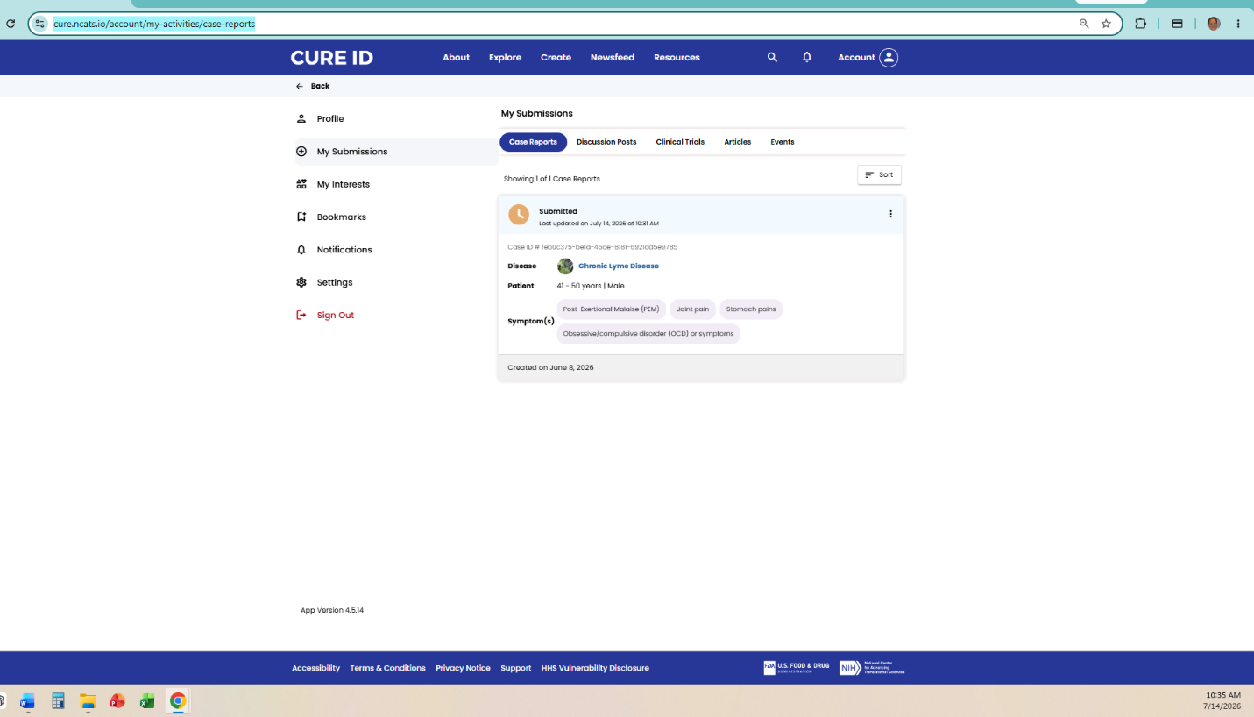
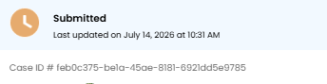

https://mail.google.com/mail/u/0?ui=2&ik=3d31b2e7a0&attid=0.0.1&permmsgid=msg-f:1870701578647889934&th=19f6112ca411e80e&view=fimg&fur=ip&permmsgid=msg-f:1870701578647889934&sz=s0-l75-ft&attbid=ANGjdJ_STbalE9DWsx3G4j9JDTtCcfpEQBS6iWFBOXOVcbrixsRfHOSyY3Eg03nG5FQeM5mnV3wG4tQYAYAPio6RtznK0x3a2NXqv0EcPbV1lDV0sD_ZAo-V4EZhj8Q&disp=emb&realattid=ii_mrkrd9s91&zw&auditContext=prefetch

