Lyme Signal
Where Patient Experience Becomes a Living Library of Shared Knowledge
Helping the Lyme Community Learn from Itself
A Pilot Implementation for the LymeX Healthathon

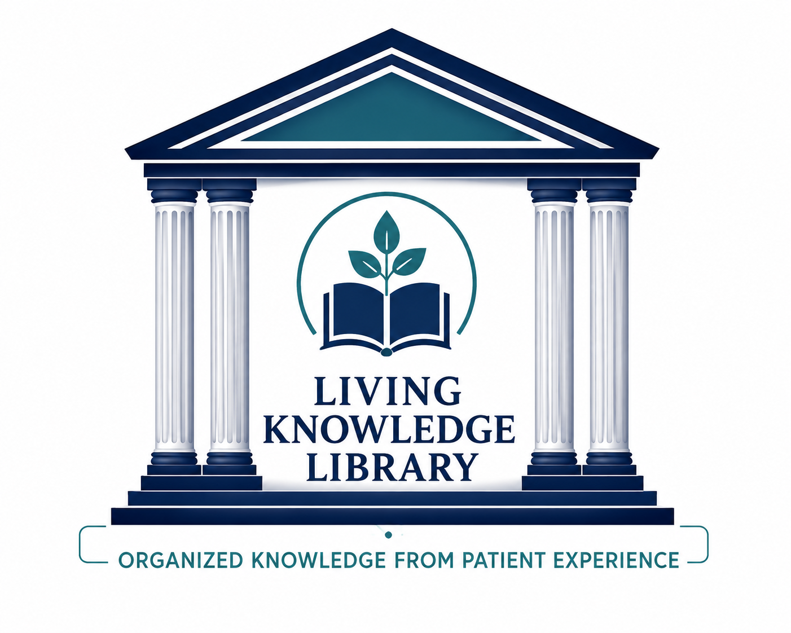

Every patient story has value. Together, those stories become shared knowledge. Lyme signal helps the entire community learn from them.

Please use the following link to view the prototype.
Please note that this prototype is intended to demonstrate the feasibility of collecting and organizing patient-reported data. The current version focuses on functionality rather than the final user interface or visual design.

Lyme Signal · Streamlit

Every Day...

Every day, thousands of people living with Lyme disease search online hoping to find someone whose story sounds like their own.

They read forums, community discussions, and personal accounts looking for understanding. They find patients describing symptoms, diagnostic journeys, treatments they have tried, setbacks, small victories, and unanswered questions.

These stories represent one of the richest collections of lived experience in the Lyme community. Yet the knowledge inside them remains scattered across countless conversations.

Patients search for hours. Clinicians rarely have time to review years of discussions. Researchers cannot manually read thousands of narratives and connect every recurring pattern.

The knowledge already exists. It simply is not organized.
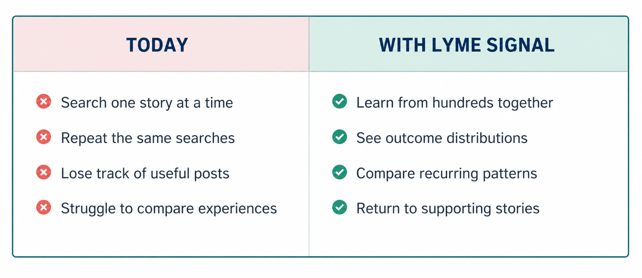
Meet Someone Like Sarah
Imagine someone living with Lyme disease. She wakes up exhausted, her symptoms change from week to week, and she spends evenings searching online for answers.
She visits forums, reads Reddit, searches long discussion threads, and finds hundreds of stories.
Some sound exactly like hers. Others completely contradict one another. She bookmarks dozens of posts, but later cannot remember where she read them.
She has learned many individual stories, but she still cannot answer one simple question:
What is the Lyme community experiencing as a whole?
Sarah does not need another 500 disconnected stories. She needs help understanding what those 500 stories are saying together.
Lyme Signal changes that.
This Is the Problem Lyme Signal Solves
A person should never have to read 500 individual patient stories just to answer questions like:
• What are patients saying helped fatigue?
• What are patients saying did not help brain fog?
• Which interventions are patients discussing most often?
• Where do patient experiences consistently agree?
• Where do they strongly disagree?
• What questions keep appearing over and over?
• What should researchers investigate next?

Lyme Signal answers those questions in minutes or seconds, not weeks.
That is the magic. Lyme Signal does not simply collect patient stories.
It reveals what hundreds of patient stories are saying at once and summarizes it so the information is available at your fingertips in seconds.

What Lyme Signal Actually Does

Lyme Signal uses artificial intelligence to transform hundreds of publicly shared patient experiences into organized, searchable community knowledge.
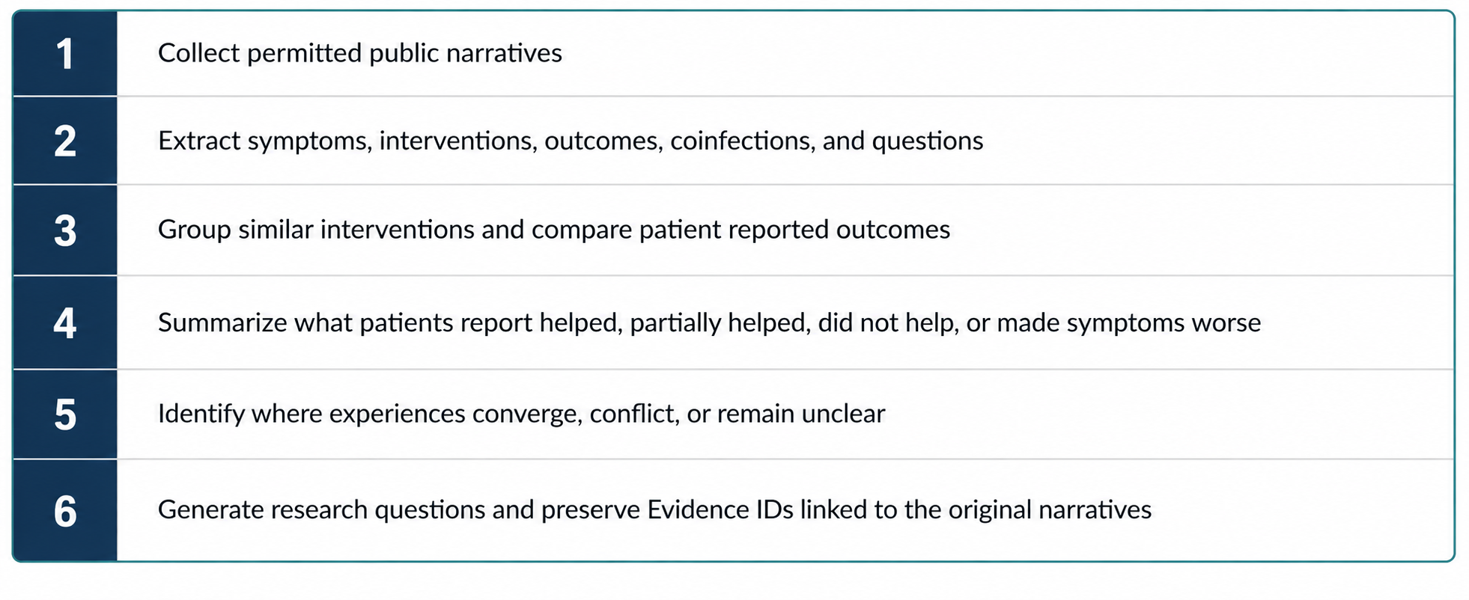
The technology is not the innovation. The innovation is making lived experience understandable.

Imagine Opening Lyme Signal

You search: Fatigue

Within seconds, Lyme Signal can show:

- The interventions patients report trying
- What patients report improved
- Partial improvement
- No improvement
- Worsening experiences
- Symptoms commonly reported together
- Frequently mentioned coinfections
- Areas of agreement and disagreement
- Emerging research questions
- Evidence IDs linked to the original stories

Instead of reading hundreds of posts, you understand what hundreds of posts are saying together.

Illustrative Lyme Signal Output

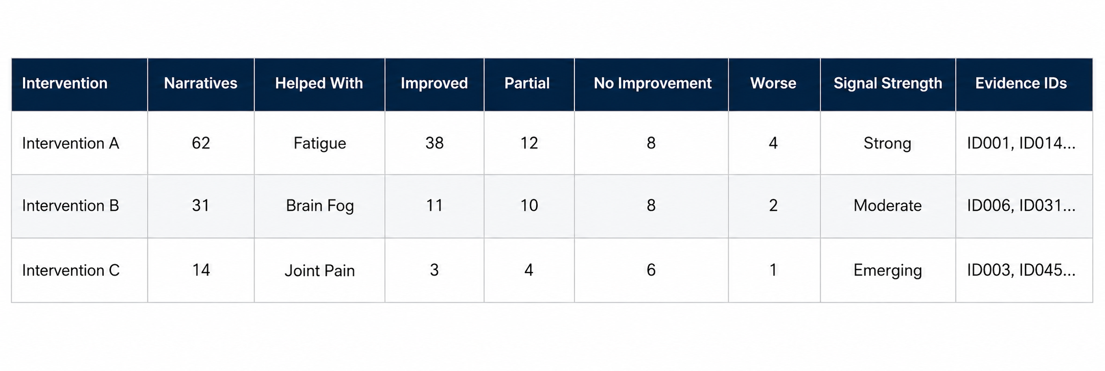
The table below is an example of the intended output structure. The values are illustrative only and must be replaced with validated pilot findings.
Patient Signal Strength Key
Patient Signal Strength describes how frequently and consistently an experience appears within the pilot dataset. It does not measure clinical effectiveness
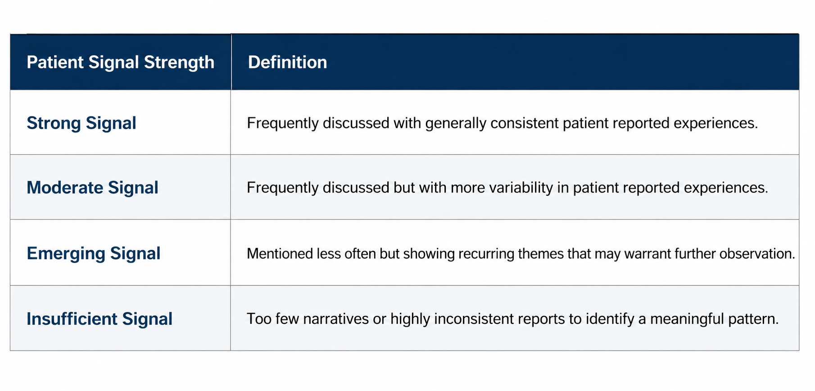

Why Lyme Signal Matters Today

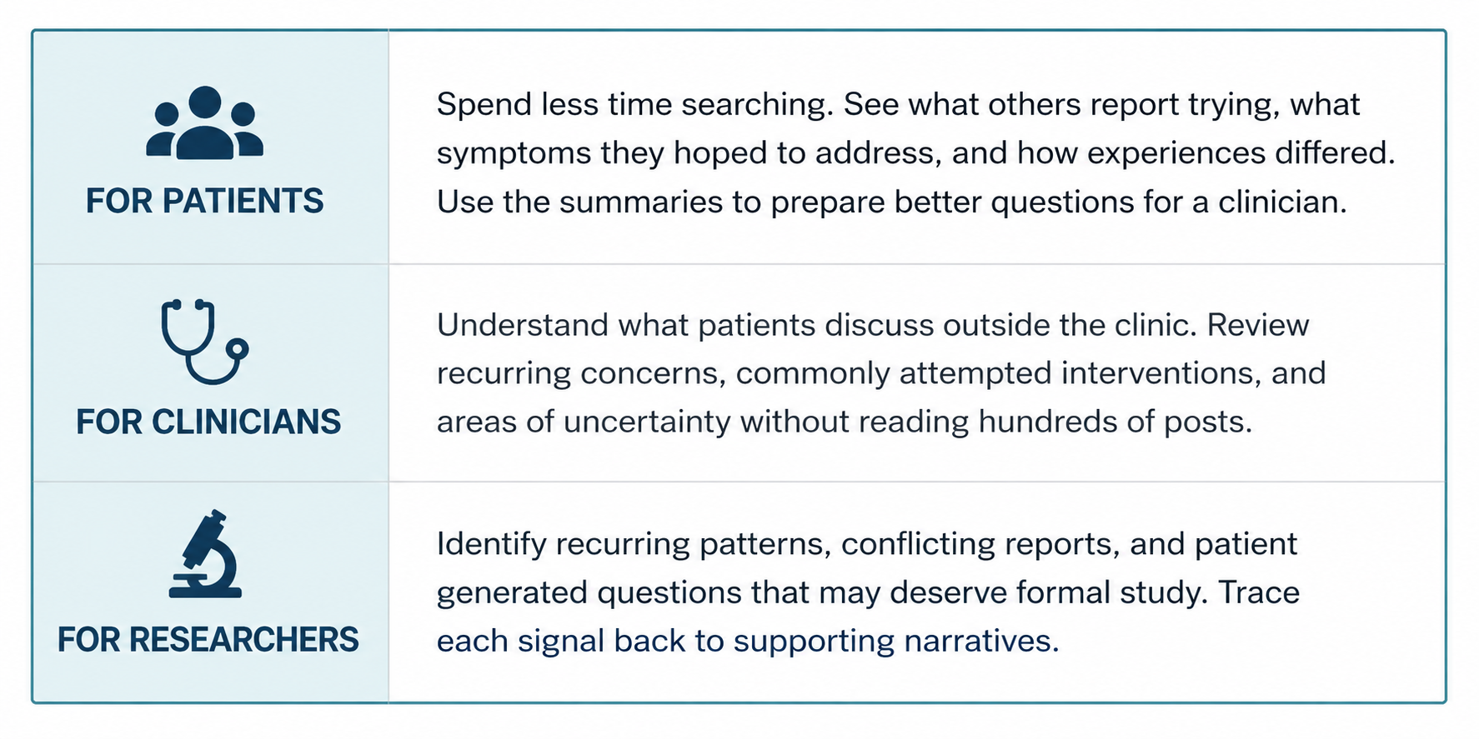
Lyme Signal does not replace patient stories. It helps people understand them.
Patient Experience Is Constantly Evolving

Patients are constantly posting new experiences. They try new approaches, describe changing symptoms, report setbacks and improvements, and raise questions that may not yet appear in formal research.

Without a way to organize this information, much of it becomes buried beneath newer discussions. The individual story remains online, but the knowledge inside it becomes difficult to find and even harder to compare.

Lyme Signal is designed as a continuously updated shared knowledge resource. As new permitted public narratives are added, the system can refresh its summaries, counts, outcome distributions, and emerging research questions.

Think of it like a weather report for lived experience.

A weather report does not ask people to interpret thousands of raw observations. It organizes those observations into a clear picture of current conditions.

In the same way, Lyme Signal can organize continuously changing patient reports into a clearer picture of what the Lyme community is discussing and experiencing now.

It does not predict the future. It helps the community
better understand the present.
Lyme Signal is a Living Library That is Constantly Evolving
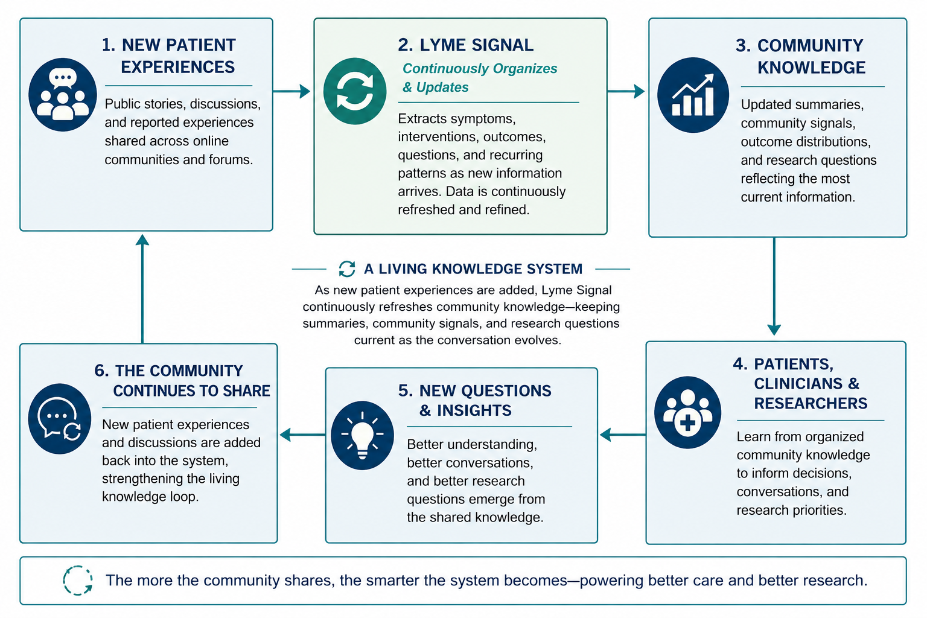
Every new story can strengthen the living library. Every new perspective can help refine what the community understands.

Example Community Signal Report Generated by Lyme Signal
The table below illustrates the type of report Lyme Signal is designed to generate. Instead of manually reviewing hundreds of patient narratives, Lyme Signal organizes recurring community experiences into structured observations and potential research questions. The findings shown below are illustrative; in a completed pilot, they would be generated from the analyzed pilot dataset and continuously updated as new patient experiences are added.

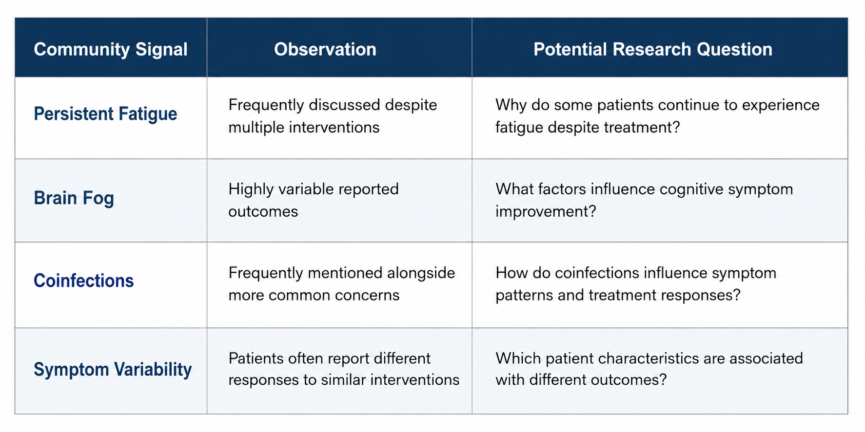

Building Trust Into Lyme Signal
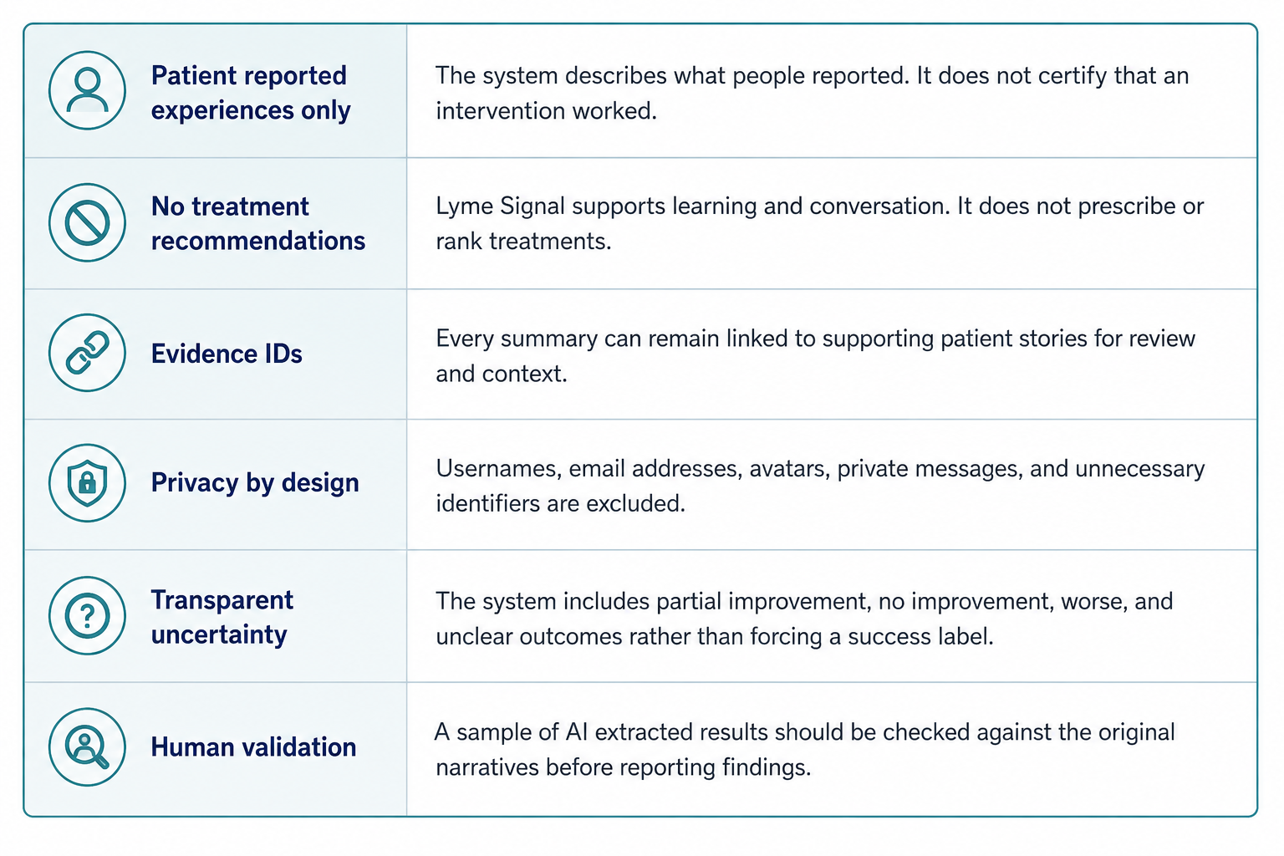
Imagine What Becomes Possible

Imagine a newly diagnosed patient opening Lyme Signal and understanding within minutes what the community has reported about fatigue, brain fog, sleep, pain, or another concern.

Imagine a clinician quickly reviewing the range of patient reported experiences before a visit, without trying to interpret hundreds of scattered posts.

Imagine a researcher seeing which questions patients have asked repeatedly, where experiences conflict, and which emerging topics may deserve formal investigation. Every new story strengthens the living library. Every new perspective helps the Lyme community learn from itself.

The pilot demonstrates that this work can begin now. Future development can make the resource more current, more searchable, more representative, and more useful without changing its central purpose.

One Story Can Help One Person
Thousands of organized stories can help an entire
community.
Every patient story begins with one person's experience. Together, those experiences become something larger. They become shared knowledge. They become opportunities to improve understanding.
They become better questions. They become hope for the next person searching for answers.
Every patient story has value. Together, those stories become shared knowledge. Lyme Signal helps the entire community learn from them.
The answers may not exist in any one story. But together, patient stories can help us ask better
questions.

PART II

(Mock Ups: App Version 1)

Seeing Lyme Signal in Action

The following pages illustrate how Lyme Signal transforms patient experiences into organized community knowledge that can continuously evolve as new stories are shared.

Lyme Signal Community Weather Report (Future Vision)

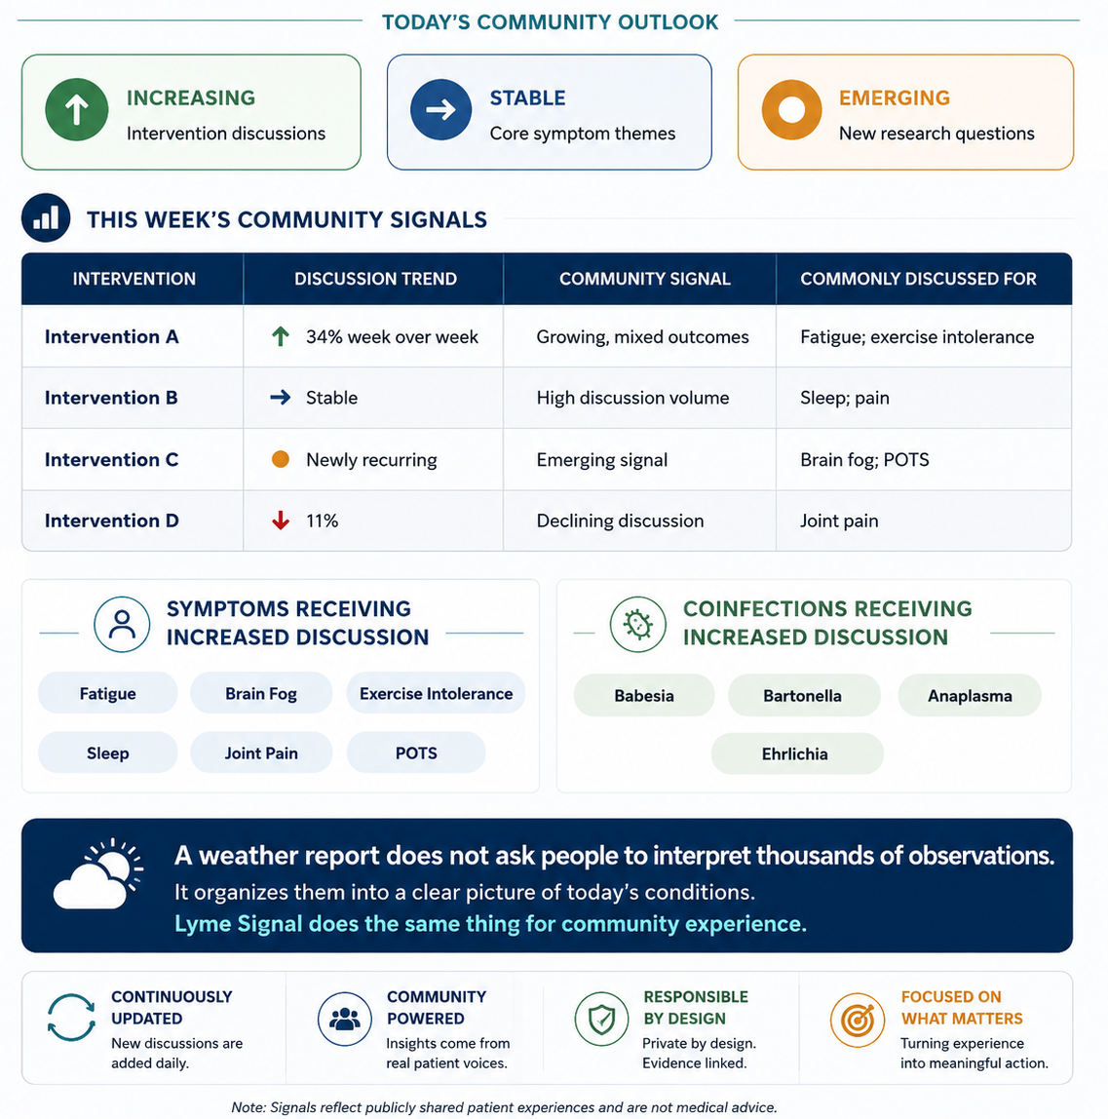
A continuously updated snapshot of what the Lyme community is discussing, trying, and reporting.

What Is Changing and What Should We Ask Next?
The value of a living system is not only showing what is discussed. It is revealing where the community attention, uncertainty and questions are moving.

Community Signal Dashboard
A realistic view of how patients, clinicians, and researchers could explore the living knowledge system.
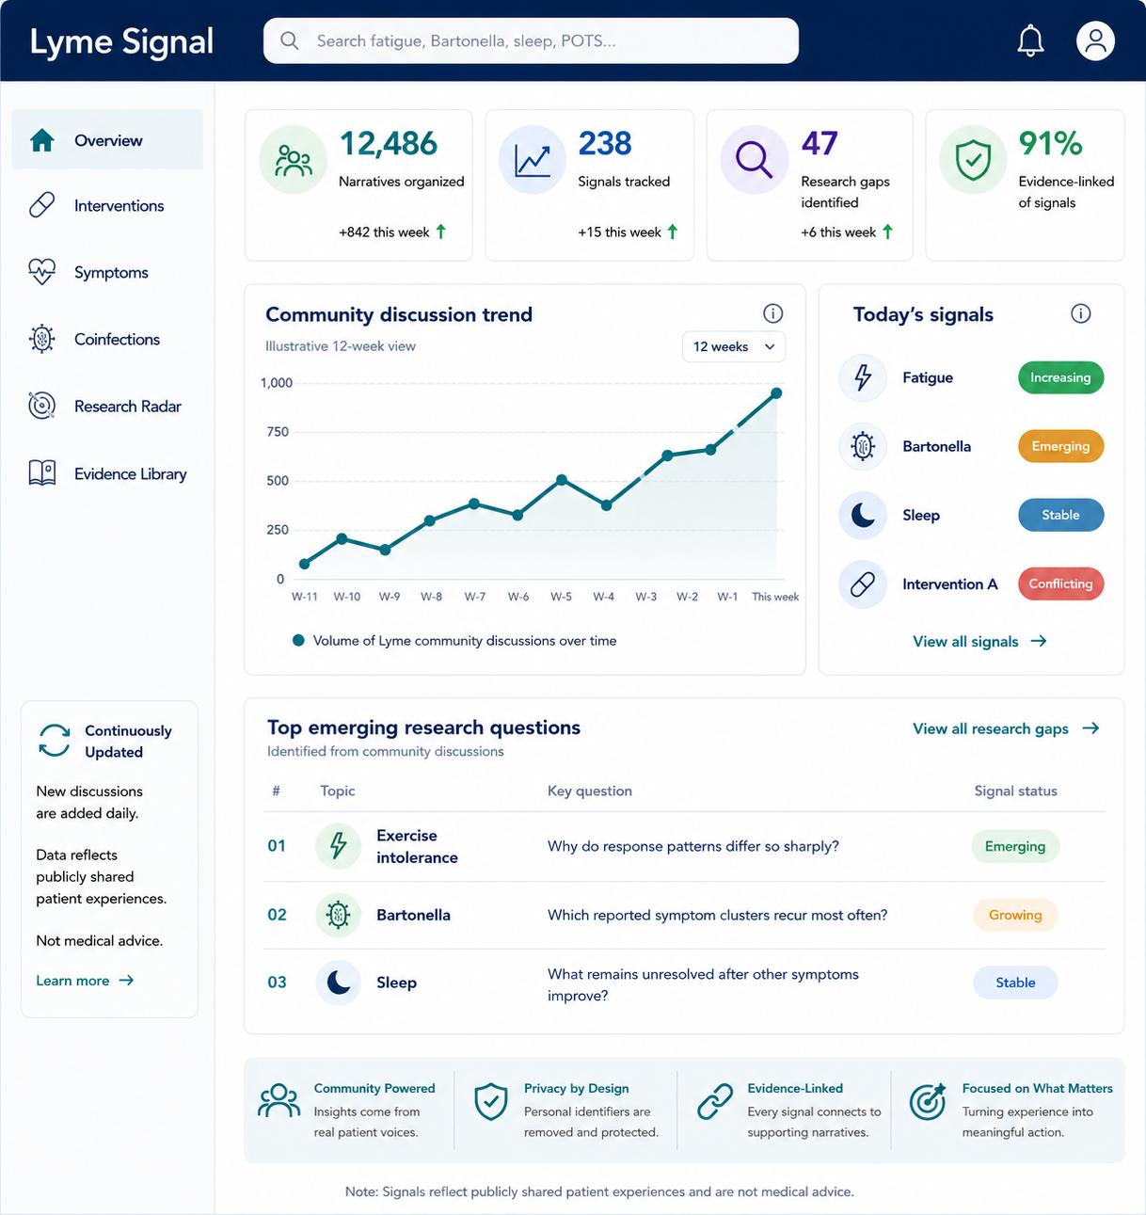

The Living Knowledge Loop

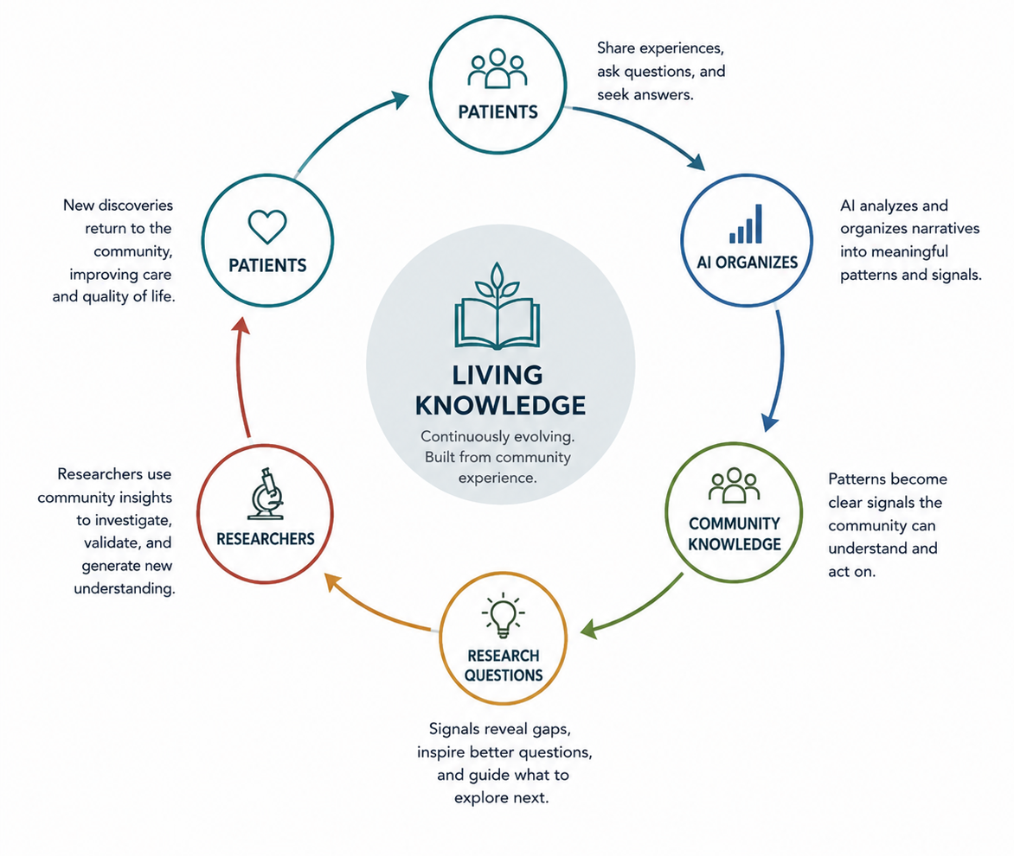
Knowledge does not end when a story is organized. It returns to the community as better questions, better understanding and new discovery.

Every new story can refresh the system. Every refreshed signal can sharpen the next question.

